**MCj01493760000[1]**

**How to Take a Mental Vacation**

To prepare for your mental vacation, relax your muscles and take a few deep breaths. Then close your eyes and imagine you are someplace you enjoy. Try to fully experience this imagined event.

What do you see?

What do you hear?

What does the air feel like?

What do you smell?

Tune in to the sense of well-being. At first, you should allow 10 to 15 minutes for this exercise. As you become more adept you will find that you can feel like you have been on a long vacation or just come back from a good time in just a few moments.

Adapted from*: Stress Management for Parents* (2004). Child Development Institute [Online] Available: <http://www.childdevelopmentinfo.com/parenting/stress.shtml>. [2004, October 24]

**Calming Breath Exercise**

Breathing from your abdomen, inhale through your nose slowly to a count of five (count slowly "one…two…three…four…five" as you inhale).

Pause and hold your breath to a count of five.

Exhale slowly, through your nose or mouth, to a count of five (or more if it takes you longer). Be sure to exhale fully.

When you’ve exhaled completely, take two breaths in your normal rhythm, and then repeat steps 1 through 3 in the cycle above.

Optional: Each time you exhale, you may wish to say "relax," "calm," let go," or any other relaxing word or phrase silently to yourself. Allow your whole body to let go as you do this.

Practice the calming breath exercise for five minutes every day for at least two weeks. If possible, find a regular time each day to do this so that your breathing exercise becomes a habit. Once you feel you’ve gained some mastery in the use of the technique, apply it when you feel stressed, anxious, or angry.

Adapted from: Bourne, E.J. (1995). The Anxiety and Phobia Workbook , Oakland: New Harbinger.

### All Behavior Has Meaning:

### Being a Behavior Detective

When our children misbehave, it’s sometimes hard to manage our anger and stay in control of our feelings. This is especially true if we don’t take the time to stop and think about why our children are misbehaving. Changing the way we think can help us better handle the times when our children act out.

C:\Users\spaula\AppData\Local\Microsoft\Windows\Temporary Internet Files\Content.IE5\NZ84TH7J\MC900031061[1].wmfChildren usually misbehave for a reason. Almost always, they act out because they have a legitimate want or need. They just don’t know how to go about getting what they need in appropriate ways. Most children misbehave because they need or want:

* Attention or Connection Seeking
* Comfort and reassurance
* Escape from a difficult or uncomfortable situation
* To feel in control when scared or anxious
* Physical activity
* Expression of feelings

Understanding why a child is misbehaving helps us avoid misinterpreting the child's intentions or concluding that "he's just bad," or "she's just out to give me a hard time."

Understanding the reasons for misbehavior helps us decide how we will handle the situation.

**Before Responding, Ask Yourself…**

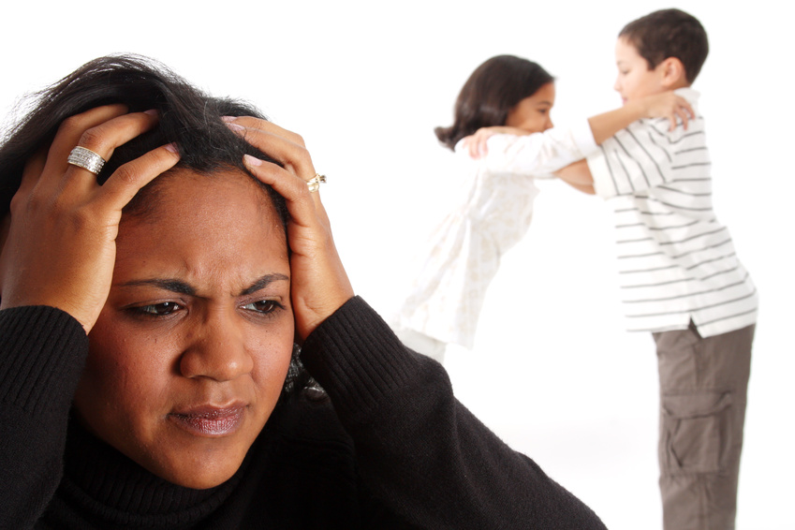

What am I feeling now?

What does this child need or want?

How can I best respond to this situation?