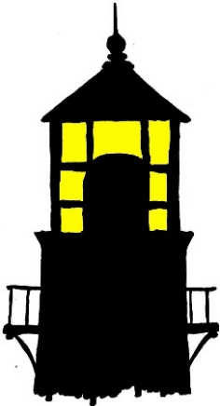
2018

PECK SLIP
READ-A-THON

KEEP THE LIGHT
ON THIS SUMMER!
2018
Peck Slip School Summer Read-a-Thon

Service Project
In addition to reading this summer, your kids may choose to participate in our Read-a-Thon Summer Service Project.

Students collect pledges from family & friends to raise money for the Lighthouse Guild (lighthouseguild.org), a leading New York City not-for-profit organization with a long-standing heritage of addressing the needs of adults and children who are blind or visually impaired.

How does it work?

- Ask family and friends to be a sponsor for a chosen amount of money per book read. Use the attached Mad Libs style letter, or write your own!

- When a family member or friend agrees to sponsor your child, have them fill out the attached pledge sheet. Older kids can even do the math to figure out how much money to collect at the end!

- Collect the pledge money and turn it by September 14th when they hand in their reading log. Checks should be made out to The Lighthouse Guild.

The money we raise will be presented to the Lighthouse Guild at our awards ceremony in the fall.

For more information about the Lighthouse Guild NYC, please go to www.lighthouseguild.org.

*Please note that this is NOT a mandatory part of the Peck Slip Summer Read-a-Thon, and will not have any bearing on the awards ceremony. The summer service project is completely optional!

